**ConQuest of Vlaicu**

*ConQuest of Vlaicu* is the best way to make your school a friend, or just get mad of being tested even in your free time. This game is made for entertainment and learning. We developed this game in order to bring the school in a bright light by testing your real abilities, your concentration, your patience and to give you a mysterious story about our favorite teachers. The idea of this game has been evolving for a few months and now it takes shape. The game tries to take you by surprise and let you imagine a happy ending, but does the school have a happy ending?

**The team**

Our team consists of Moisa Nicolae (Nicu), Hristache Alexandru (Alex) and our supervisor Popa Daniel. We learned programming during the freshman year of high school and we loved it. We have always been trying to improve our skills. Alex made all the objects and designed the classrooms and Nicu wrote the quests and built the gameplay. The treasure hunt idea of this project was our supervisor’s then it became an educational game then it changed into an escape room and we developed the game around it. Then we upgraded the story and we transformed it into a mind-blowing mystery and here we are. We have been always improving each other’s work finding solutions together for the problems encountered.

**Storyline** (a countdown to extinction)

The main storyline of the game is an attempt to escape the school as we all have tried before and will always do. Now you don’t have to run away from responsibilities, you must run for your life. You are in the middle of a devastating storm and you were caught in the school building. The authorities came to rescue all the students and school staff but in that mess they missed one, you!

Now you have to find your way out when you discover some mysterious things. You are the only witness of a fraudulent misuse of funds and maybe a murder. This must never take place or the school you know will never be the same. As the damage caused by the storm may destroy the evidence you must find them all and put them together.

You need to stop this evil plan so your new objective becomes to reveal the truth. The classrooms are now empty and lifeless and so they will be forever if you fail. And you discover there are many teachers involved in a plot. It seems there is no hope for the school unless you can reach the exit and take a stand.

But the real meaning of the story is that it follows a student’s life from the beginning when he is afraid of everything and thinks his teachers want just to show him how small and helpless he is with their incomprehensible things to learn, to “murder” his ideas and to steal his free time. Then he realizes the real meaning of hard work, the teachers trying to “conquer” his school years become his foremost allies. All the quests you have to accomplish in this game are a symbol of the information you are always seeking and, in the long run you realize the real meaning of all things you have ever learnt in the school. Escaping from school means your progresses made throughout high school years and only in the last time you realize that all quests you had to do make sense and their purpose was to prepare yourself for life. You witness the extinction of childhood and train for getting out in the cold.

**The game**

It’s a 3D game with a first-person controller gameplay. The main objective of the game is finding different objects hidden in the classrooms. The game stimulates your thinking in finding the hiding places and makes you wonder about what happens next.

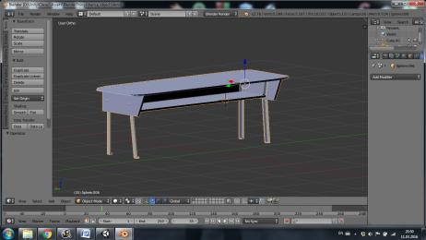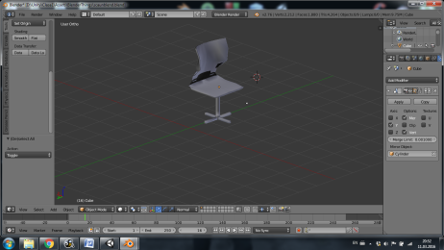

The game was made and developed by us from A to Z. First we have designed the objects in the classroom together then we have divided in order to work more easily. All furniture and objects were made in Blender v2.76, this was Alex’s job. He tried to make everything look as similar as possible to our school. All models were simplified a bit but with a very suggestive amount of details and put into their position. He used photos of school’s furniture to make the virtual furniture needed to bring shape to our classrooms. First of all, he made each object individually trying to keep it as close to the original as possible. Everything from desks and chairs to keys and books was designed by Alex.

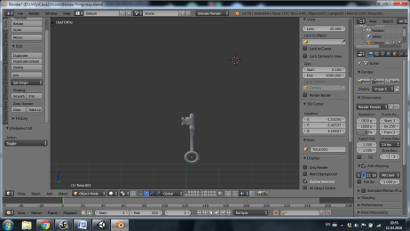 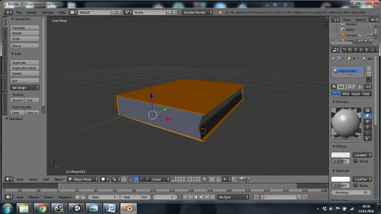

Alex put all pieces together and built the third floor of our school. The textures were downloaded from the internet as it’s impossible for an amateur to take a suggestive picture of texture because of variation of light and quality. However the hall paving is made using a picture taken by us. Textures and colors try to reproduce a virtual reflection of the real ones. We must admit we have never felt this school so close until we had to search for every relevant detail of the school’s structure. One of the hardest parts of the building was always paying attention to details like shades, orientation, dynamics or position of the objects. All the models imported from blender are located in the folder named “Blender things”. We have included the school’s plans in the uploaded files.

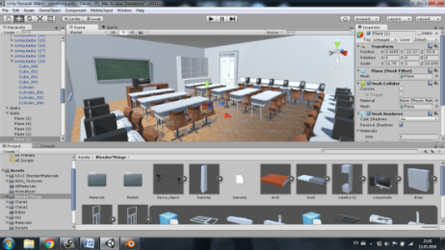 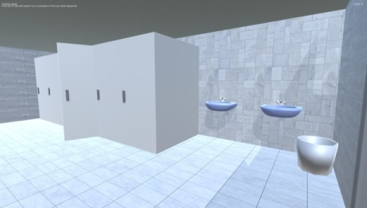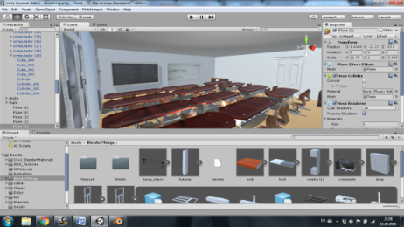

Nicu has written the scripts for interactive objects. He used C# as programming language. The programming part was the other hardest part of this project as it had to keep up with the storyline. Variables used are named suggestively to the things they refer to so the scripts are easy to understand. The principle of events is using Empty Objects which are set inactive where their goal is met. Quests are active successively so you can’t complete quest2 before quest1 or you can’t pick an item if it’s not the right time. A summary of your current quest is displayed in the upper left corner.

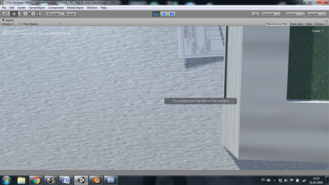

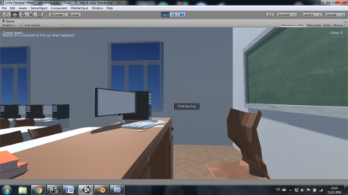

You have to find a key in order to open a drawer

Hidden clue you have to find

using UnityEngine;  
using System.Collections;  
  
public class InteractScript : MonoBehaviour {  
    public float interactDistance = 15f;  
    void Update () {  
          
        if (Input.GetKeyDown ("e")) {  
            Ray ray = new Ray (transform.position,transform.forward);  
            RaycastHit hit;  
            if(Physics.Raycast(ray,out hit,interactDistance))  
             if (hit.collider.CompareTag ("Door"))  
       hit.collider.transform.parent.GetComponent<DoorScript> ().ChangeDoorState ();  
        }  
    }  
  
}

This is the interact script for the door. It’s used to open doors of any kind whether they are glass case doors or class doors. This script uses another script called DoorScript which is a door’s component. The following script uses an Empty object as a hinge. The door itself rotates around it and gives the effect of an opening door. isOpen is an Empty object which is set inactive if the door is open and active if the door is closed. It could have used a static variable but using an Empty object is more malleable because there are some things hidden in the glass case and, in order to not pick them through the closed door, they must be in a relationship with the door and it’s easier to just drag the isOpen GameObject in another script then opening this one to remember the name of the variable.

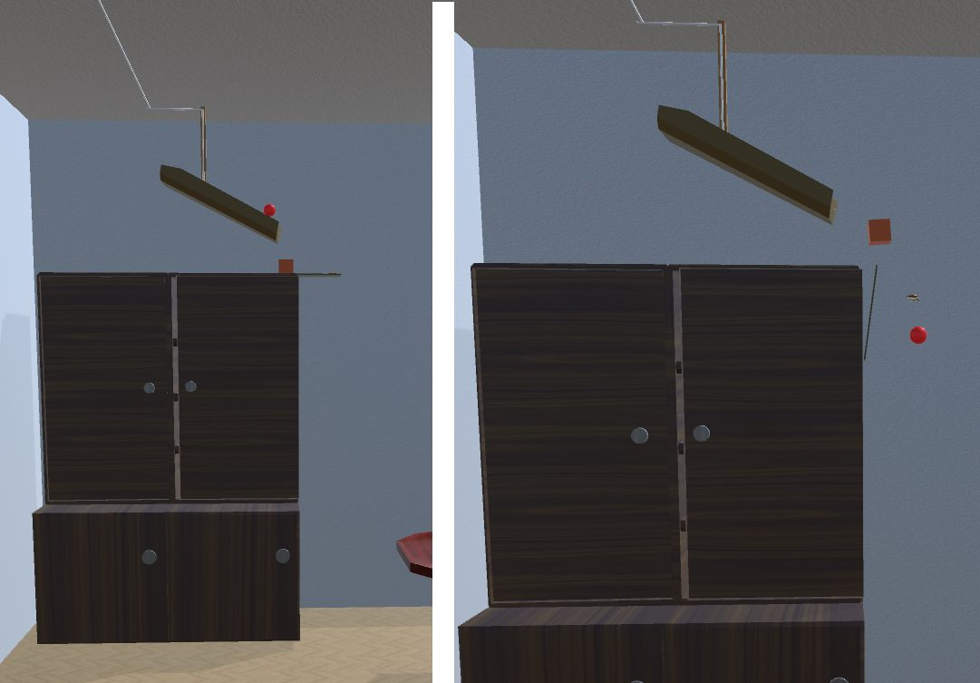

using UnityEngine;  
using System.Collections;  
  
public class DoorScript : MonoBehaviour {  
    public bool open = false;  
    public float doorOpenAngle;  
    public float doorCloseAngle;  
    public float smooth=2f;  
    public GameObject isOpen;

    public void ChangeDoorState()  
    {  
        open = !open;  
    }  
    void Update () {  
          
        if (open) {  
            Quaternion targetRotation = Quaternion.Euler (0, doorOpenAngle, 0);  
            transform.localRotation = Quaternion.Slerp (transform.localRotation, targetRotation, smooth* Time.deltaTime);  
            isOpen.SetActive (false);  
        }  
        else {  
            Quaternion targetRotation2 = Quaternion.Euler (0, doorCloseAngle, 0);  
            transform.localRotation = Quaternion.Slerp (transform.localRotation, targetRotation2, smooth* Time.deltaTime);  
            isOpen.SetActive (true);  
        }  
  
    }  
}

The game also has a **money system**. You can collect all kinds of money: coins or paper money and then spend it on coffee. We found it funny to implement our currency and make the money look like the real ones. You must search every corner of the rooms in order to get rich. Yea, even when you have to fight for your life you think about money. For that an easy script was used which uses a static variable which increases with the coin value when found. Your current amount of money is always displayed in the upper right corner. With money you can buy coffee from the coffee vending machine. There’s a **stamina bar** under the money counter and you have to be careful to get some coffee before it gets too low. If the bar reaches 0, you pass out and the game restarts. This makes the game a challenge

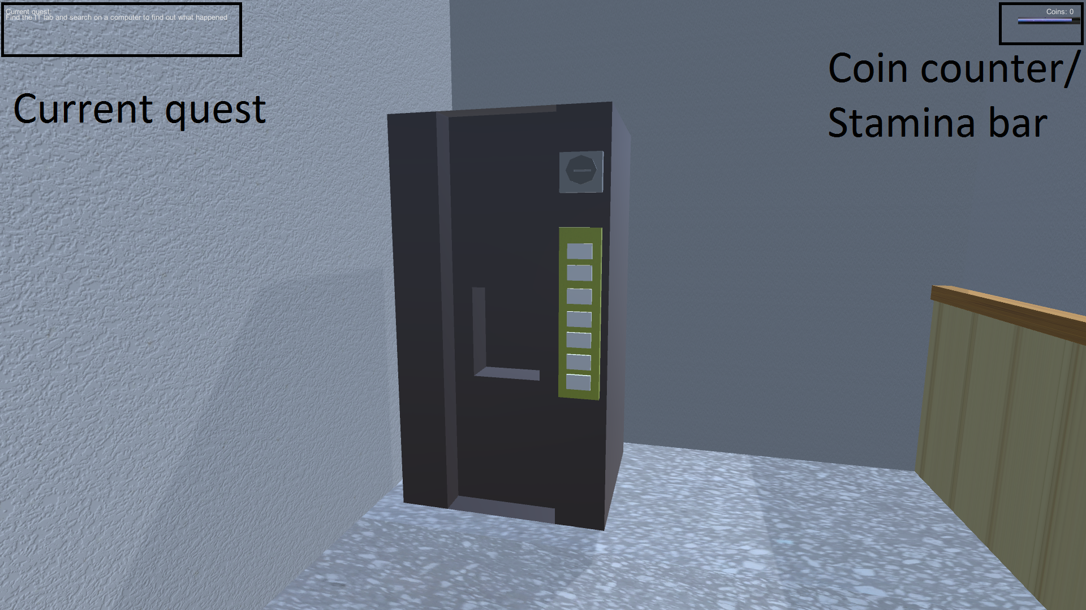

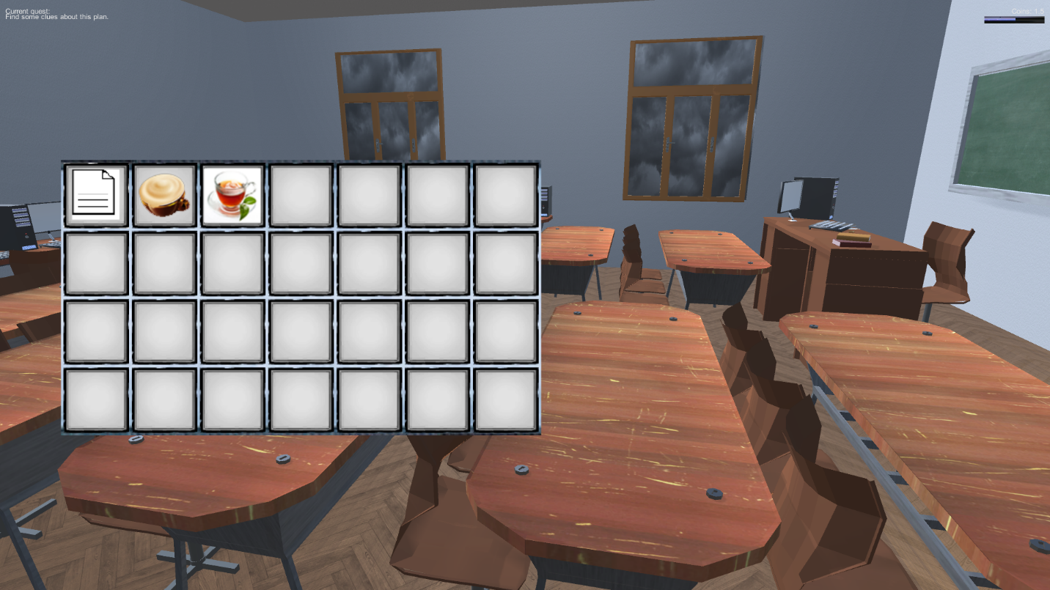

**The Inventory**

By pressing ‘I’ you open the inventory. Some of the items you have to use later are stored there. Also, the coffee you buy goes to your inventory and can be used whenever you want. You can right-click the items in order to use them, or change their place in the inventory.

**System Requirements**

***Recommended***

Processor: Intel® Core™ i5-4210U CPU @ 2.40Ghz

RAM: 2.00 GB

GPU: nvidia GeForce 820M 2Gb DDR3

DirectX DX 11.0

Hard Disk free space 100 MB

**To do list**

* Creating more classrooms
* Adding random elements to the game
* Improving the graphics of the game

This project was made to test our skills and for entertainment. We tried to come up with a nice gameplay and an exciting and original story. Any resemblance to reality was intended and was taken to extreme. We hope you enjoy the game and remember the school as an adventure not as a prison. You will get the satisfaction of breaking the law and do whatever you want in this virtual school with no rules, no teachers, no homework and no grades.